Correlation and Covariance Assignment

Question1.
Define Covariance and explain how it differs from Correlation in terms of scale and interpretation.
Ans.
$$\underline{Covariance}$$
Covariance measures how two random variables change together.
1. If both variables tend to increase or decrease simultaneously, the covariance is positive.
2. If one increases while the other decreases, the covariance is negative.
3. If they are independent, the covariance is close to zero.
When x changes what actually happens to y?
Example:
1. Study time , Marks obtained
If study time increases the marks will increase also. (Positive covariance).
2. Speed of a car, time taken to cover a distance
If speed of a car increases then the time taken to cover a distance will decrease.(Negative covariance).
3. Size of a shoes, blood group
Blood group is nothing to do with the size of the shoes.(Zero covariance).

$$\underline{Correlation}$$
Correlation is a standardized version of covariance. It measures both the strength and direction of the linear relationship between two variables.
The range of the Correlation lies between -1 to +1.
1. Positive Correlation or Perfect positive relationship
When the value of correlation is close to equal to +1.
2. Negative Correlation or Perfect negative relationship
When the value of correlation is close to equal to -1.
3. Zero Correlation or No relationship
When the value of correlation is equal to 0.

Covariance is differs from Correlation in terms of:
1.Scale
Covariance depends on the units of the variables (e.g., kg·cm, dollars·hours).
Where As
Correlation is Unitless, always between -1 and +1.
2.Interpretation
Covariance only tells direction (positive/negative) of relationship, not strength.
Where As
Correlation tells both direction and strength of linear relationship.

Question2.
What does a positive, negative, and zero covariance indicate about the relationship between two variables?
Ans.
In statistics, covariance measures the directional relationship between two random variables. It essentially tells you whether the variables tend to move in the same direction or in opposite directions.
The relationship is determined by the sign of the covariance value:
1.Positive Covariance
A positive covariance indicates a direct relationship between the two variables. As the value of one variable increases, the other variable also tends to increase. Conversely, when one decreases, the other tends to decrease.
Example: Height and weight usually have a positive covariance; taller people generally weigh more.

2. Negative Covariance
A negative covariance indicates an inverse relationship between the two variables. As one variable increases, the other variable tends to decrease. They move in opposite directions.
Example: The amount of time spent playing video games and the time spent studying for an exam might have a negative covariance.

3. Zero Covariance
A zero covariance (or a value very close to zero) indicates that there is no linear relationship between the variables.
Example: The price of tea in London and the number of goals scored in a local soccer match would likely have zero covariance.

Question3.
Discuss the limitations of covariance as a measure of relationship between two variables. Why is correlation preferred in many cases?
Ans.
While covariance is a fundamental tool for identifying the direction of a relationship, it has significant practical limitations that make it difficult to use for deep analysis.
1. Scale Dependency
The value of covariance depends entirely on the units of measurement. This makes it impossible to compare relationships between different datasets.
2. Lack of Magnitude (Strength)
Covariance only tells you the direction, but it does not tell you the strength of the relationship.
Why Correlation is Preferred
Correlation is essentially "standardized covariance." It is calculated by dividing the covariance by the product of the standard deviations of the two variables:
Because of this standardization, correlation offers three major advantages:
1. Fixed Range: Correlation is always between -1 and +1.
2. Scale Independence: It is unitless. Whether you measure in miles or kilometers, the correlation coefficient stays exactly the same. This allows you to compare the relationship of "Price vs. Demand" directly against "Temperature vs. Sales.

Question4.
Explain the difference between Pearson’s correlation coefficient and Spearman’s rank correlation coefficient. When would you prefer to use Spearman’s correlation?
Ans.
1 Pearson’s Correlation (r)
Pearson’s is a parametric test that measures the strength and direction of a linear relationship.
Assumes both variables are normally distributed (or at least continuous and interval-scaled).
Sensitive to outliers because it uses raw values.
Sensitive to outliers because it uses raw values.

2 Spearman’s Rank Correlation(p)
Spearman’s is a non-parametric test that measures a monotonic relationship. Instead of using raw values, it converts data into ranks (1st, 2nd, 3rd...) and then calculates the correlation between those ranks.
Works with ordinal data (ranked values).
Works with ordinal data (ranked values).
Captures monotonic relationships (whether increasing or decreasing), not just linear ones.
When to Prefer Spearman’s Correlation
1 Data are ordinal (ranked but not evenly spaced)
2 The relationship is monotonic but not linear (e.g., as one variable increases, the other consistently increases or decreases, but not at a constant rate).
3 Variables don’t meet the assumptions of normality or equal variance.
4 If dataset contains outliers that could distort Pearson’s correlation.

Question5.
If the correlation coefficient between two variables X and Y is 0.85, interpret this value in context. Can you infer causation from this value? Why or why not?
Ans.
The correlation coefficient (r) ranges from -1 to +1.
A value of 0.85 means:
There is a strong positive linear relationship between X and Y.
As X increases, Y tends to increase as well (and vice versa).
The relationship is quite consistent, though not perfect.
Can We Infer Causation?
No, correlation does not imply causation.
Reasons:
1.Directionality problem:
We don’t know if X causes Y, Y causes X, or both influence each other.
2.Third-variable problem:
A hidden factor (confounder) might be influencing both.
Example: Ice cream sales and drowning incidents are positively correlated, but the hidden factor is temperature (hot weather increases both).
3.Correlation only measures association, not the underlying mechanism.

Question6.
Using the dataset below, calculate the covariance between X and Y.
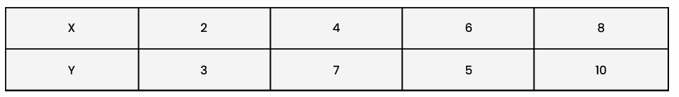
Ans.
Formula: Cov(x-$\overline{x}$)(y-$\overline{y}$)/(n-1)
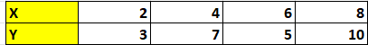
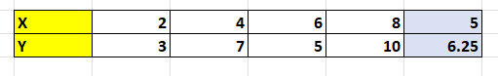
Mean of X ($\overline{x}$)=5
Mean of X ($\overline{y}$)=6.25
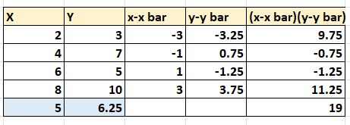
n=4
Cov(X,Y) = ∑(x-$\overline{x}$)(y-$\overline{y}$)/(n-1)
= 19/(4-1)
= 19/3
=6.33.
It is positive covariance that means when X increase Y will also increase or when X decrease Y will also decrease.
X and Y are moving together in the same direction.

Question7.
Compute the Pearson correlation coefficient between variables A and B.
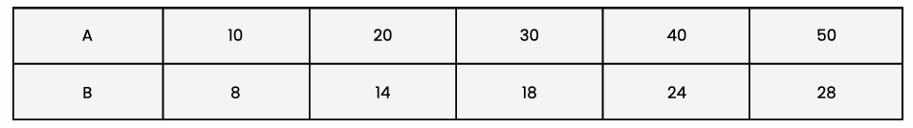
Ans.
Using Excel, find all the values.
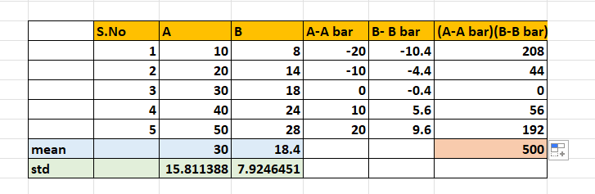
Mean of A ($\overline{A}$)=30
Mean of B ($\overline{B}$)=18.4
Standard Deviation of A (S_{A})=15.81
Standard Deviation of B (S_{B})=7.92
n=5
Calculate Covariance between A and B
Formula: Cov(A,B)= ∑(A-$\overline{A}$)(B-$\overline{B}$)/(n-1)

Put all the values in formula:
Cov(A,B)= ∑(A-$\overline{A}$)(B-$\overline{B}$)/(n-1)
=500/5-1
=500/4
= 125.

Now, calculate correlation between A and B.
Formula: Cor(A,B)= cov(A,B)/( S_{A} * S_{B})
= 125/(15.81*7.92)
= 125/125.21
=0.99
Covariance=125, Positive value means they tend to move in the same direction.
Correlation=0.99, positive relationship.
Pearson r ≈ 0.99 Extremely strong positive correlation.
As A increases, B increases almost perfectly in sync.

Question8.
The following table shows heights (in cm) and weights (in kg) of 5 students. Find the correlation coefficient between Height and Weight.
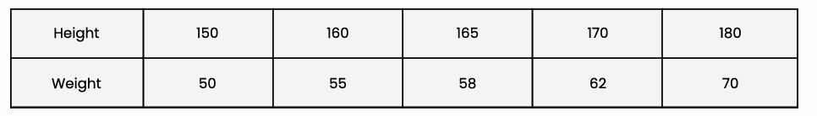
Ans.
Using Excel formulas, find all the values.
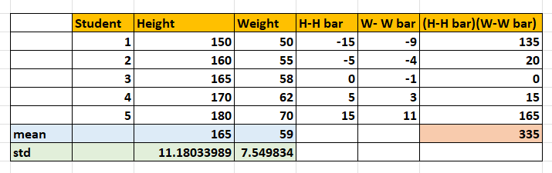
Mean of H ($\overline{H}$)=165
Mean of W ($\overline{W}$)=59
Standard Deviation of H (S_{H})=11.18
Standard Deviation of W (S_{W})=7.54
n=5
Calculate Covariance between height and weight
Formula: Cov(H,W)= ∑(H-$\overline{H}$)(W-$\overline{W}$)/(n-1)

Put all the values in formula:
Cov(A,B)= ∑(H-$\overline{H}$)(W-$\overline{W}$)/(n-1)
=335/5-1
=335/4
= 83.75.

Now, calculate correlation between height and weight.
Formula: Cor(H,W)= cov(H,W)/( S_{H} * S_{W})
= 83.75/(11.18*7.54)
= 83.75/84.3
=0.99

Covariance=83.75, Positive value means they tend to move in the same direction.
Correlation=0.99, Very strong positive relationship.
As height increases, weight tends to increase too.

Question9.
Given the dataset below, determine whether there is a positive or negative correlation between X and Y. (No need for exact calculation, just reasoning.).
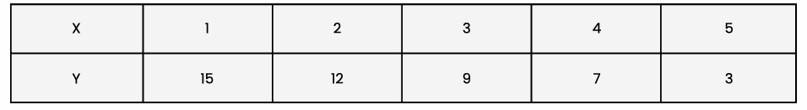
Ans.
First: Without calculation.
This dataset shows a clear negative correlation between variables X and Y.
As X increases from 1 to 5, Y decreases from 15 to 3, that means higher values of X are associated with lower values of Y.

Second: With calculation.
Calculate Covariance between X and Y
Formula: Cov(X,Y)= ∑(x-$\overline{x}$)(y-$\overline{y}$)/(n-1)
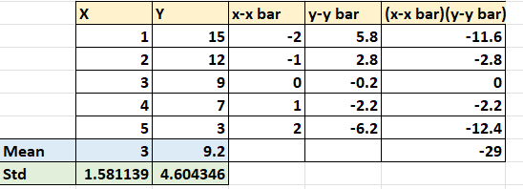
Using excel find all the values.
Mean of X ($\overline{x}$)=3
Mean of X ($\overline{y}$)=9.2
Standard Deviation of X (Sx)=1.581
Standard Deviation of Y (Sy)=4.604
n=5
Put all the values in formula:
Cov(X,Y)= ∑(x-$\overline{x}$)(y-$\overline{y}$)/(n-1)
=-29/5-1
=-29/4
= -7.25.
Negative covariance.
Now, calculate correlation between X and Y
Formula: Cor(X,Y)= cov(X,Y)/(Sx * Sy)
= -7.25/(1.581*4.604)
= -7.25/7.27
=-0.99
It is negative correlation.

Question10.
Two investment portfolios have the following returns (%) over 5 years. Compute the covariance and correlation coefficient, and interpret whether the portfolios move together.
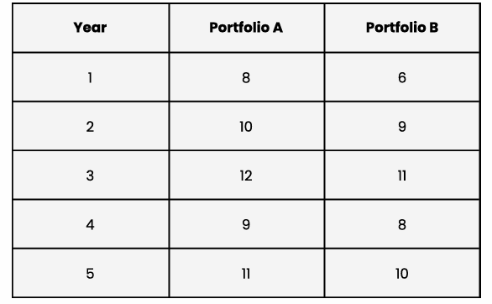
Ans.
Using Excel formula, find all the values.
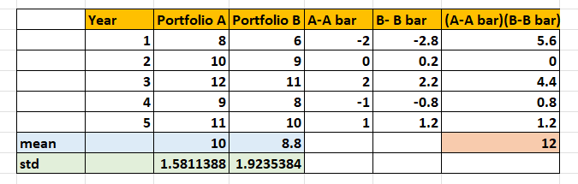
Mean of A ($\overline{A}$)=10
Mean of B ($\overline{B}$)=8.8
Standard Deviation of A (S_{A})=1.581
Standard Deviation of B (S_{B})=1.923
n=5
Calculate Covariance between Portfolio A and Portfolio B
Formula: Cov(A,B)= ∑(A-$\overline{A}$)(B-$\overline{B}$)/(n-1)

Put all the values in formula:
Cov(A,B)= ∑(A-$\overline{A}$)(B-$\overline{B}$)/(n-1)
=12/5-1
=-12/4
= 3.

Now, calculate correlation between Portfolio A and Portfolio B.
Formula: Cor(A,B)= cov(A,B)/( S_{A} * S_{B})
= 3/(1.581*1.923)
= 3/3.04
=0.98

Covariance=3, Positive value means they tend to move in the same direction.
Correlation=0.98, Very strong positive relationship.
Therefore, the portfolios will move together.

